**MATLAB/Octave - Control statements**

**#create zeros vector for later use**

>> v = zeros(10,1)

v =

0

0

0

0

0

0

0

0

0

0

**#for loop implementation**

>> for i=1:10,

v(i) = 2^i;

end;

>> v

v =

2

4

8

16

32

64

128

256

512

1024

**#same as above but with different approach**

>> indices = 1:10

indices =

1 2 3 4 5 6 7 8 9 10

>> for i=indices,

disp(i);

end;

1

2

3

4

5

6

7

8

9

10

**#print vector 'v'**

>> v

v =

2

4

8

16

32

64

128

256

512

1024

**#while loop implementation**

>> i=1;

>> while i <= 5,

v(i) = 100;

i = i+1;

end;

>> v

v =

100

100

100

100

100

64

128

256

512

1024

**#while loop implementation with different approach**

>> i=1;

>> while true,

v(i) = 999;

i = i+1;

if i==6,

break;

end;

end;

**#print modified vector**

>> v

v =

999

999

999

999

999

64

128

256

512

1024

**#change value of first element for later use**

>> v(1)

ans =

999

**#if then else implementation**

>> v(1) = 2;

>> if v(1)==1,

disp('The value is one');

elseif v(1)==2,

disp('The value is two');

else

disp('The value is not one or two');

end;

The value is two

**#user defined function - create local file containing function definition with 'filename.m' extension, call the function**



>> squareThisNumber(5)

ans =

25

**#same as above but with different function definition**



>> [a, b] = squareAndCubeThisNumber(2)

a =

4

b =

8

**#Define a function to compute the cost function J(theta)**

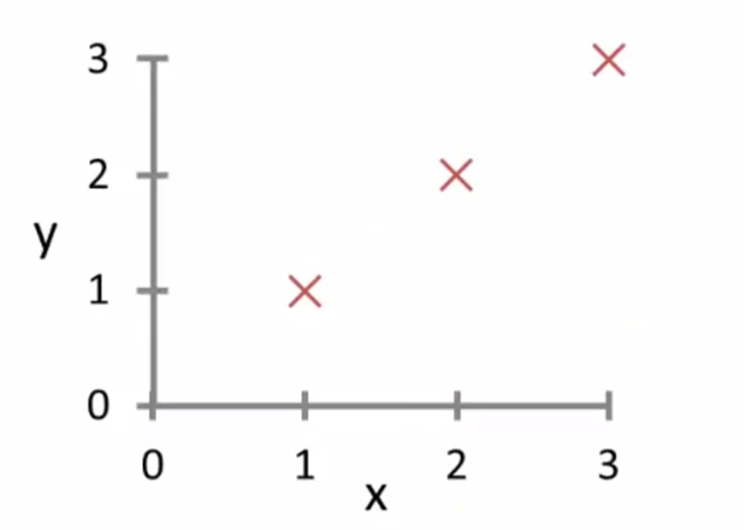

**#create feature matrix**

>> X = [1 1; 1 2; 1 3]

X =

1 1

1 2

1 3

**#create prediction vector**

>> Y = [1; 2; 3]

Y =

1

2

3

**#create parameters vector**

>> theta = [0; 1]

theta =

0

1

**#call user defined function to calculate cost function**



>> costFunctionJ(X, Y, theta)

ans =

0

**#check for different values of theta**

>> theta = [0; 0]

theta =

0

0

**#call user defined function to calculate cost function**

>> costFunctionJ(X, Y, theta)

ans =

2.3333